**5.1 USE CASE DIAGRAMS**

**FitON**

Use Case Narrative

The Fiton App is an online marketplace application that facilitates buyer-seller interactions for product purchases. It consists of multiple modules to handle various functionalities such as user registration, product browsing, order management, and communication.

Actors:

* Buyer: The primary user who registers, browses products, places orders, and communicates with sellers.
* Seller: Provides responses to buyer inquiries and engages in chats.
* System: Handles automated processes such as payment processing.
* Shop: Facilitates order confirmation.

Use Cases:

1. Customer Registration Module:
   * Register as a Buyer: Allows users to sign up.
   * Send Registration Confirmation *(Included use case)*: Sends a confirmation message to the buyer.
   * Log In: Enables registered buyers to log into the system.
2. Product Browsing Module:
   * Browse Products: Buyers can navigate through available products.
   * View Product Details: Displays information about a selected product.
   * Display Product Details *(Included use case)*: Ensures detailed product descriptions.
   * Add Product to Cart: Allows buyers to prepare for checkout.
3. Order Management Module:
   * Place an Order: Buyers can confirm their purchases.
   * Process Payment *(Included use case)*: Handles payment processing.
   * Confirm Order: The shop acknowledges the order.
   * View Order Confirmation: Buyers can verify their order details.
   * Submit a Review: Enables buyers to provide feedback.
4. Communication Module:
   * Chat with Seller: Buyers can interact with sellers.
   * Respond to Inquiry: Sellers can reply to buyer queries.

Assumptions

* The buyer must register and log in before browsing or purchasing products.
* The system will send a confirmation email upon successful registration.
* Product details must be available for browsing and purchasing.
* The order process requires successful payment processing before confirmation.
* The shop entity is responsible for final order confirmation.
* Buyers can only submit reviews for completed purchases.
* The seller is responsible for responding to buyer inquiries but is not involved in order processing.
* The system automates tasks such as sending confirmation messages and processing payments.

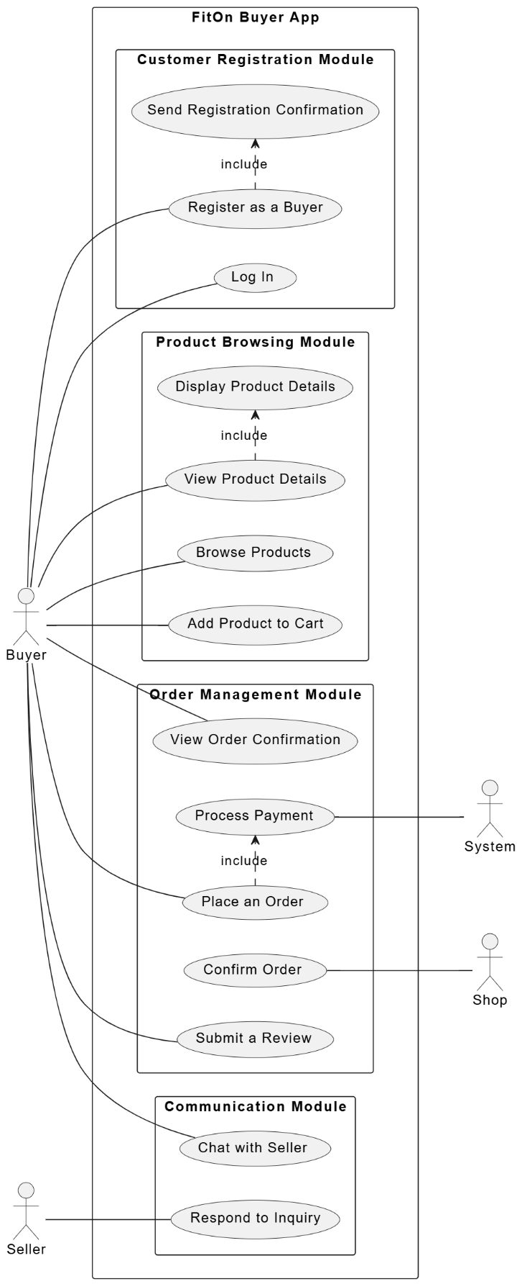

**FitON seller**

Use Case Narrative for FitOn Seller App

The FitOn Seller App is designed to allow sellers to manage their product listings, orders, and customer inquiries efficiently. It consists of multiple modules dedicated to seller registration, product management, order management, and communication.

Actors:

* Seller: The main user who registers, adds and manages products, views and updates order statuses, and interacts with buyers.
* Buyer: Can send inquiries about products listed by sellers.
* System: Handles automated processes such as payment processing and order status updates.

Use Cases:

1. Seller Registration Module:
   * Register as a Seller: Allows a new seller to register on the platform.
   * Send Registration Confirmation *(Included use case)*: Sends a confirmation message upon successful registration.
   * Log In: Enables registered sellers to access their accounts.
2. Product Management Module:
   * Add a Product: Sellers can upload new product listings.
   * Manage Products: Allows sellers to edit, update, or remove product listings.
   * Display Products to Buyer: Ensures products are visible to buyers.
3. Order Management Module:
   * View Orders: Sellers can access a list of incoming orders.
   * Update Order Status: Allows sellers to mark orders as processed, shipped, or completed.
   * Confirm Payment: Acknowledges receipt of payment.
   * Process Payments: Handles financial transactions between the buyer and seller.
   * View Order Status: Enables sellers to track the status of their orders.
4. Communication Module:
   * Send Inquiry: Buyers can ask questions about a product.
   * Respond to Inquiries: Sellers can reply to buyer questions and provide necessary information.

Assumptions

* A seller must register and log in before managing products or orders.
* The system will send a confirmation email after successful seller registration.
* Product listings must be managed efficiently to ensure accurate information is displayed to buyers.
* Order status updates must be communicated to buyers to maintain transparency.
* The system is responsible for processing payments and confirming transactions.
* Sellers are responsible for responding to buyer inquiries and ensuring a smooth customer experience.
* Buyers can only send inquiries about listed products and cannot modify seller details.

**FitON Admin app**

Use Case Narrative for Admin App

The Admin App is designed for system administrators to manage users, product listings, orders, subscriptions, and audits. The admin ensures smooth operations, maintains platform security, and oversees transactions.

Actors:

* Admin: The primary user responsible for managing the system, approving/rejecting product listings, handling users, and monitoring transactions.
* Buyer & Seller: Can view and subscribe to plans.
* System: Automates order and payment processing, records admin actions.

Use Cases:

1. Admin Management Module:
   * Log In: Allows the admin to access the system securely.
   * View Admin Profile: Displays admin details and access privileges.
2. User Management Module:
   * Manage Users: Enables admins to manage buyer and seller accounts.
   * Approve/Reject Product Listings: Admins can verify and approve/reject product listings submitted by sellers.
   * View User Profile: Allows admins to inspect detailed user information.
3. Subscription Management Module:
   * Manage Subscription Plans: Admins can create, edit, or remove subscription plans.
   * View Subscription Plan: Buyers and sellers can view available subscription plans.
   * Subscribe to Plan: Buyers and sellers can subscribe to a selected plan.
4. Order Management Module:
   * Monitor Orders: Admins can oversee order activities.
   * View Order Details: Allows admins to inspect order specifics.
   * Update Order Status: Enables admins to modify the status of orders.
   * Process Payment: Ensures secure handling of payments.
5. Audit Module:
   * Access Audit Logs: Admins can review logs of system activities for security and tracking purposes.
   * Record Admin Actions: The system logs all administrative activities.

Assumptions

* Admins must log in to access the system.
* Admins have full control over user management, subscriptions, and order processing.
* The system automatically records admin actions for accountability.
* Buyers and sellers can only interact with subscription plans and orders, while the admin has a supervisory role.
* Order and payment processing are system-driven but monitored by the admin.
* Approving or rejecting product listings ensures quality control before they appear to buyers.

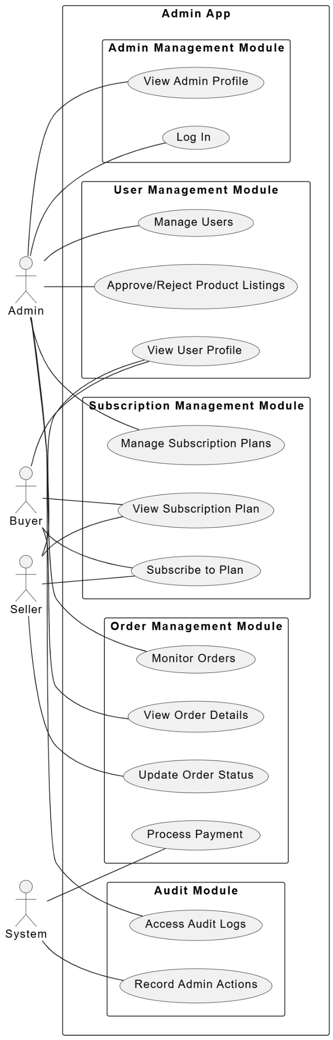

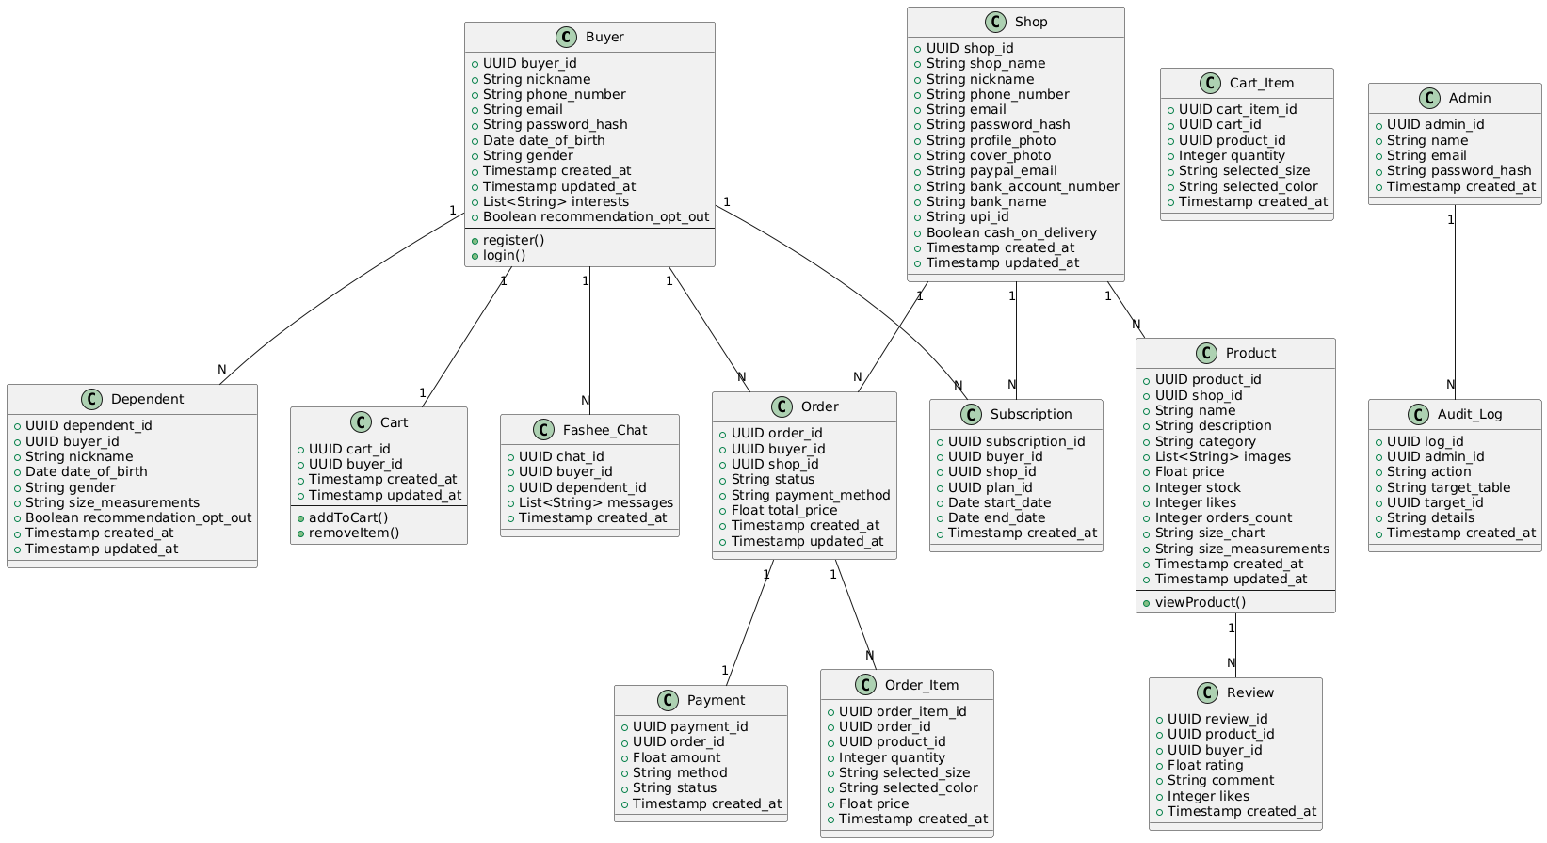**5.2 Class Diagram**

Description of the Class Diagram

This class diagram represents the database structure of an e-commerce platform that connects buyers and shops, allowing users to browse products, place orders, and manage payments. It includes multiple entities (classes) and their relationships.

Key Classes and Relationships:

1. Buyer
   * Represents customers who purchase products.
   * Can have multiple dependents (N:1 relationship).
   * Manages carts and places orders.
2. Shop
   * Represents sellers managing products and subscriptions.
   * Linked to multiple products and orders (1:N relationship).
   * Stores payment details for transactions.
3. Cart & Cart_Item
   * Buyers add products to their cart before checkout.
   * A cart contains multiple cart items, each storing selected product details.
4. Order & Order_Item
   * Buyers place orders, and each order contains multiple order items.
   * Orders are linked to payments and shops.
5. Subscription
   * Buyers subscribe to plans for premium features.
   * A subscription has a start date and end date.
6. Product
   * Shops list products with descriptions, pricing, and stock details.
   * Includes a size chart, size measurements, and a list of images.
7. Review
   * Buyers can submit reviews for purchased products.
   * Includes ratings, comments, and likes.
8. Payment
   * Stores transaction details for orders.
   * Tracks payment amount, method, and status.
9. Admin
   * Manages users, orders, and subscriptions.
   * Logs actions in the Audit_Log.
10. Fashee_Chat
    * Allows buyers to chat with shops for inquiries.
    * Messages are stored as a list of strings.
11. Audit_Log
    * Stores admin actions such as approvals and updates.

Assumptions

* Buyers must register before making purchases.
* Each shop can sell multiple products, but each product belongs to one shop.
* Each order can contain multiple items, but each item belongs to one order.
* Orders must have a payment entry before processing.
* Buyers can have dependents, meaning they may order on behalf of family members.
* A subscription is required for certain services, but buyers can still shop without one.
* Admins can track all system actions via audit logs.

**5.3 ER Diagram**

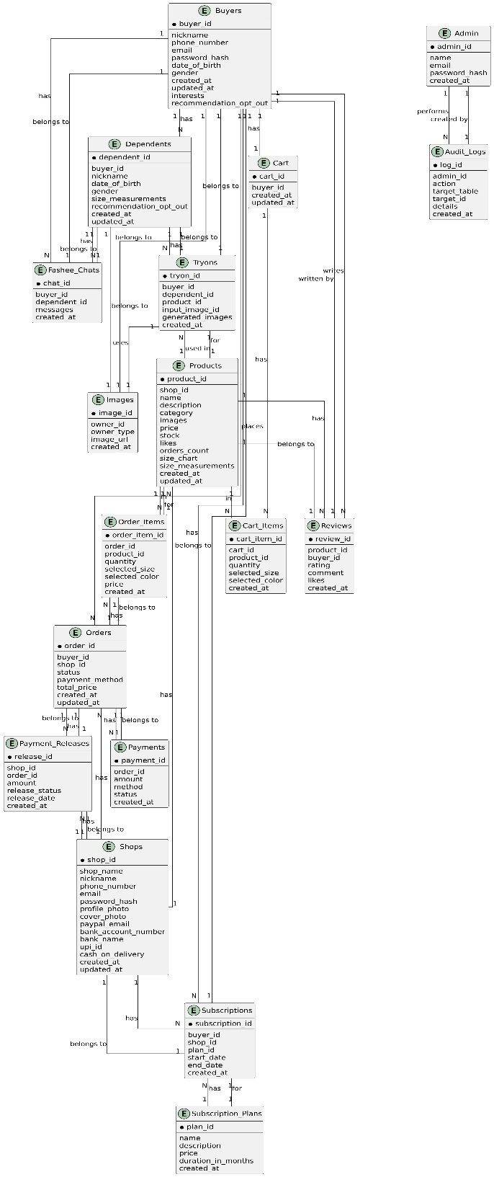

**Description of the ER Diagram**

The ER Diagram represents an e-commerce platform with a structured database for managing buyers, shops, products, orders, payments, subscriptions, and reviews. It includes multiple entities (tables) and relationships to efficiently handle the platform’s operations.

Key Entities and Relationships

1. Buyers
   * Registers on the platform and can make purchases.
   * Can have multiple dependents (N:1).
   * Each buyer has one cart (1:1).
   * Can write reviews for products (1:N).
2. Shops
   * Sellers who manage products (1:N).
   * Receives orders from buyers (1:N).
   * Can have subscriptions to different plans (N:1).
3. Products
   * Each product is linked to one shop (1:N).
   * Products are added to carts and placed in orders (N:M).
   * Can receive multiple reviews from buyers (1:N).
4. Orders
   * Each order is placed by a buyer and linked to a shop (1:N).
   * Contains multiple order items (1:N).
   * Connected to a payment (1:1).
5. Payments
   * Linked to a specific order (1:1).
   * Contains payment amount, method, and status.
6. Cart & Cart Items
   * A cart belongs to a buyer (1:1).
   * A cart contains multiple cart items (1:N).
   * Cart items reference products.
7. Reviews
   * Each review is linked to a buyer and a product (1:N).
   * Contains rating, comment, and likes.
8. Subscriptions & Subscription Plans
   * Buyers and Shops can subscribe to a subscription plan (N:1).
9. Admin & Audit Logs
   * Admin can track actions in the system (1:N).
   * Logs record admin activities such as approving/rejecting products.
10. Tryons & Images

* Tryons allow users to test products virtually.
* Images are linked to products, shops, and try-ons.

Assumptions

* Each buyer must register before making purchases.
* Each shop can sell multiple products, but each product belongs to one shop.
* Orders must have a successful payment before processing.
* Buyers can have dependents, meaning they may shop for family members.
* A subscription is required for certain services, but buyers can still shop without one.
* Admins can track system actions via audit logs.
* Each cart is linked to only one buyer, and only one active cart exists per buyer.
* Shops are responsible for managing products, and the platform does not interfere.

**5.4 Activity Diagrams**

**FitON**

Description

The activity diagram represents the workflow of a buyer on the FitOn e-commerce platform from registration to order completion, payment, review submission, and communication with the seller.

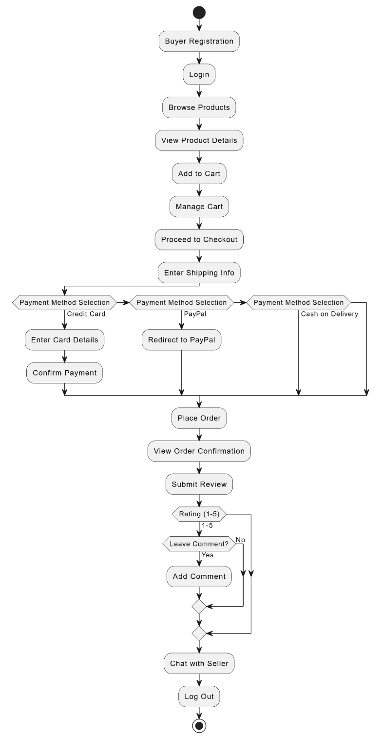

**FitON Seller**

Description

This activity diagram illustrates the workflow of a seller on the FitOn e-commerce platform, from registration to product management, order updates, and payment processing.

**FitON Admin**

Description

This activity diagram represents the workflow of an admin on the FitOn e-commerce platform, covering user management, product approvals, order monitoring, and system audits.

**5.5 Sequence Diagram for full system**

Description

This sequence diagram illustrates the interaction between different entities in the FitOn e-commerce platform, covering the buyer, shop, system, database, payment gateway, AI engine, and admin. It showcases key processes such as user registration, product browsing, order placement, payment, AI-based try-on, subscription management, reviews, and chat interactions.

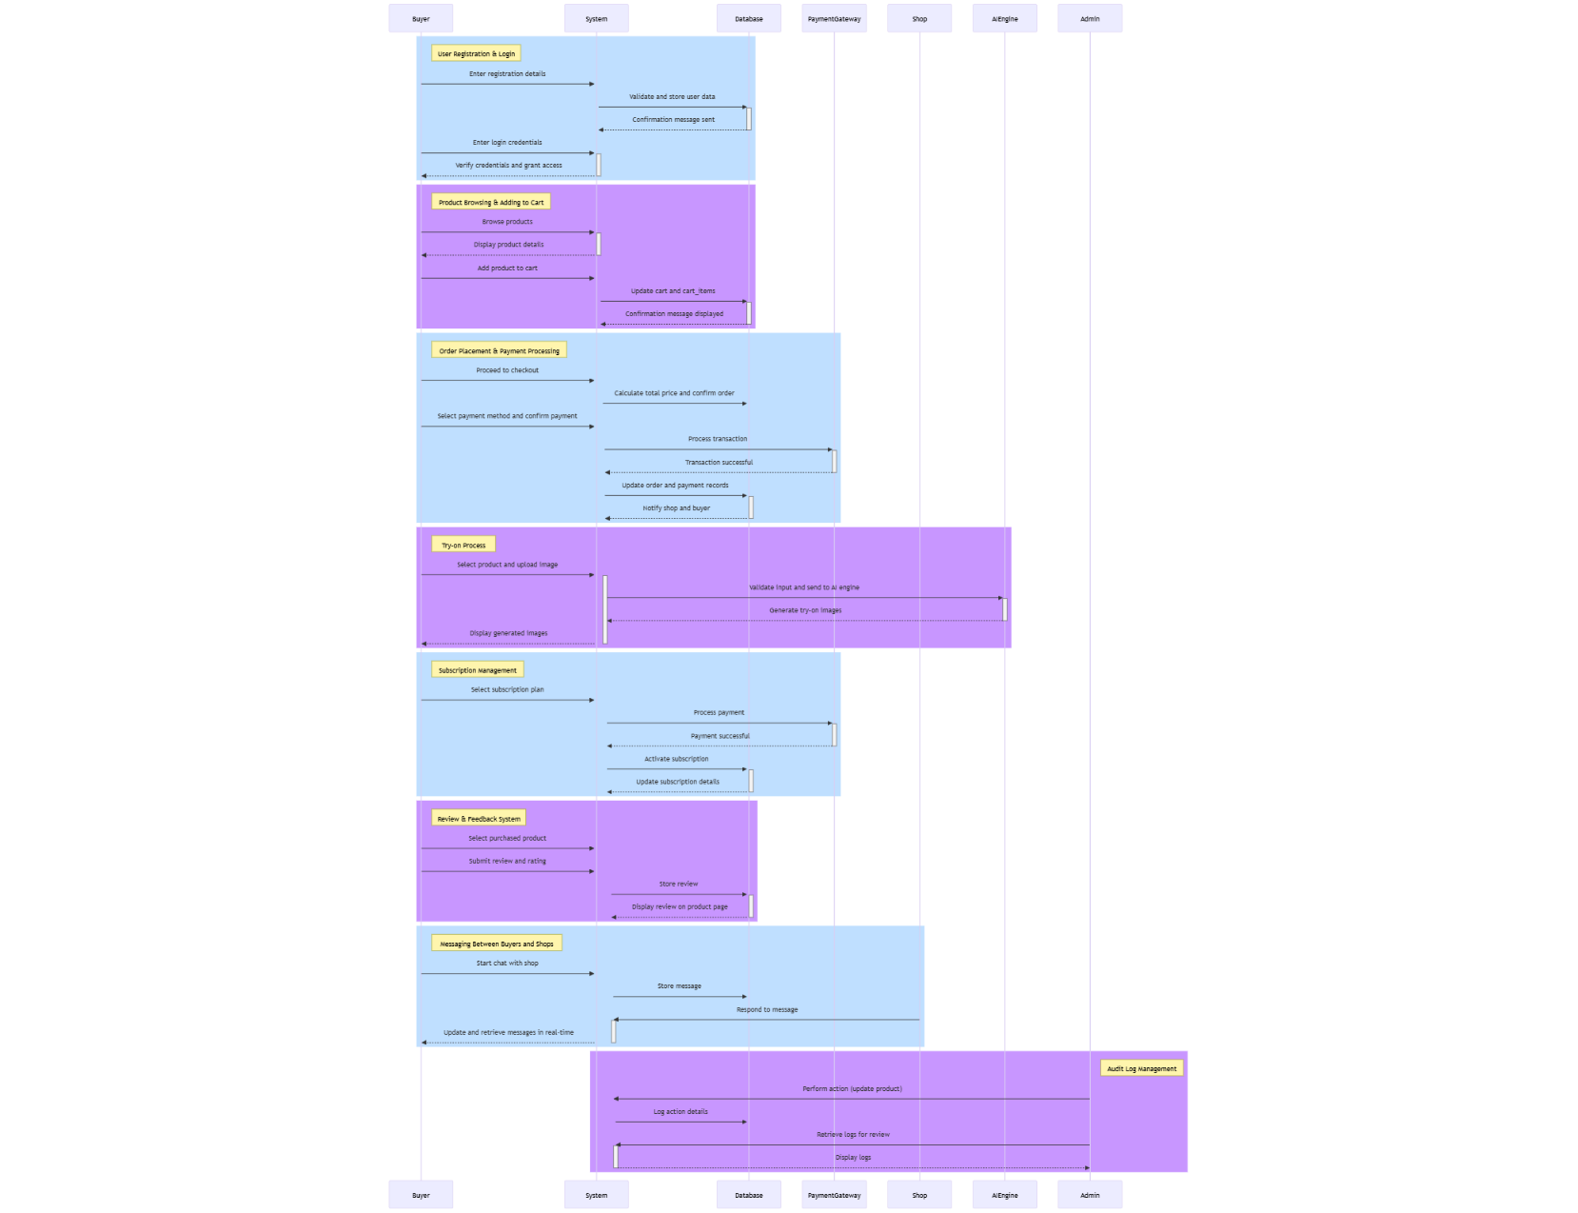

**Sequence Diagram for FitON app**

Description

This sequence diagram represents the interaction between the buyer, system, and payment gateway in the FitOn e-commerce platform for purchasing products.

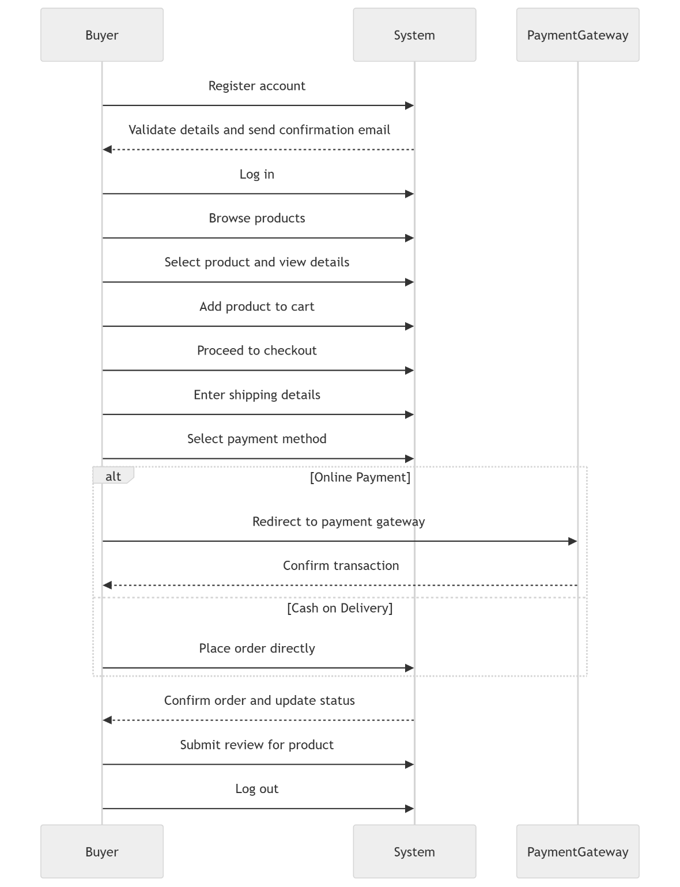

**Sequence Diagram for FitON Seller**

Description

This sequence diagram represents the interaction between the seller, system, and buyer for managing products and orders.

**Sequence Diagram for FitON Admin**

Description

This sequence diagram represents the admin’s role in managing users, products, orders, and subscriptions within the FitOn platform.

**5.6** **Network Diagram**

**5.7 Network Architecture Diagram**

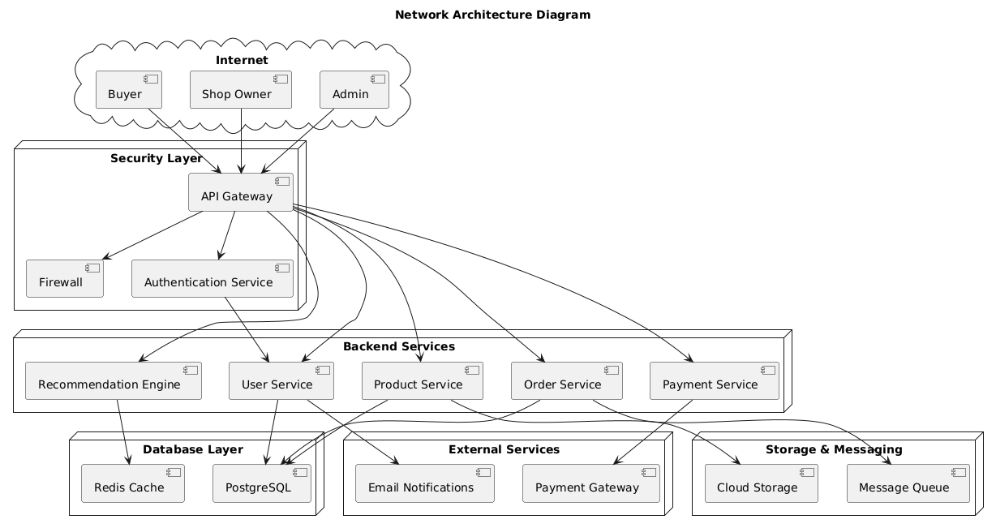

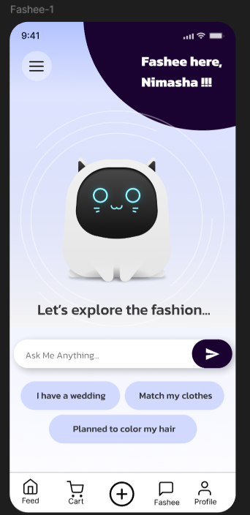**5.8 FitON App Screenshots**

**Fiton Seller App Screenshots**

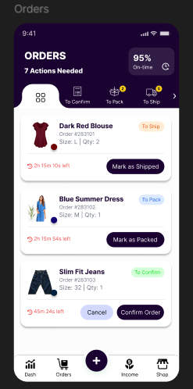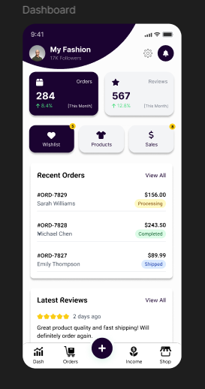

**5.9. Chapter Summery**

**All Diagrams**

* 1. **Use Case Diagrams**
  2. **Class Diagram**
  3. **ER Diagram**
  4. **Activity Diagrams**
  5. **Sequence Diagrams**
  6. **Network Diagram**
  7. **Network Architecture Diagram**